Macro-Star Networks: Efficient Low-Degree Alternatives to Star Graphs
Chi-Hsiang Yeh, Emmanouel A. Varvarigos
IEEE Transactions on Parallel and Distributed Systems, Vol.9, No. 10, October 1998, p987-1003
Abstract
We propose a new class of interconnection networks, called macro-star networks, which belong to the class of Cayley graphs and use the star graph as a basic building module.
- Introduction
The purpose of this paper is to develop a new family of parallel architectures that meet the following requirements:
- small node degree,
- small diameter,
- symmetry properties,
- efficient emulation of popular topologies,
- balanced traffic, and
- suitability for VLSI implementation.

An MS(l,n) network has N = (nl + 1)! nodes, degree n+l–1.
Balanced MS networks: An MS(l, n) network with l=Θ(n) is asymptotically within a factor of 1.25 from a universal lower bound.
- Macro-Star Networks
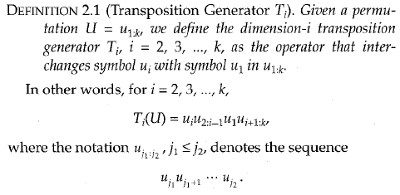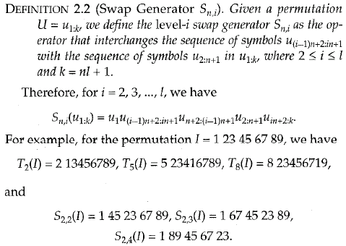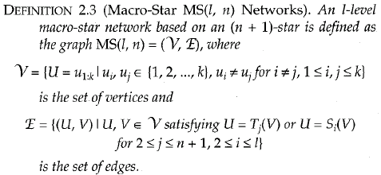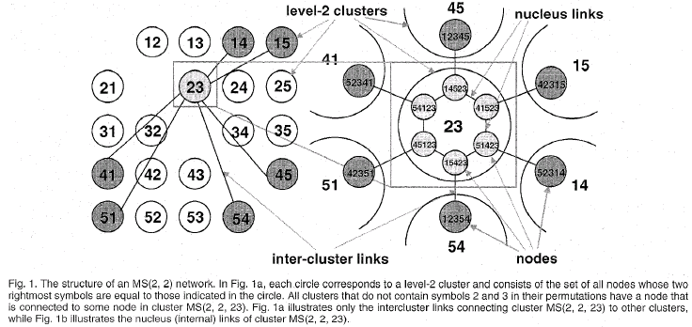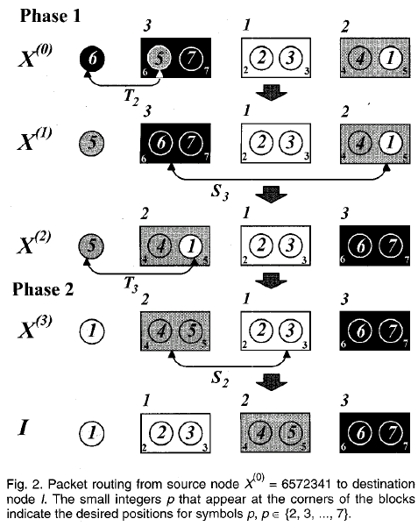
- Routing and Topological Properties
3.1 Routing in an MS Network Based on Any Star-Graph Routing Algorithm
Any Algorithm in an (ln +1)-star under the Single-Dimension Communication (SDC) model can be emulated on the MS(l,n) network with a slowdown factor of three.
3.2 Faster MS Routing Algorithms
The total number of steps required by the routing algorithm is at most equal to 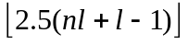 steps.
3.3 Basic Properties
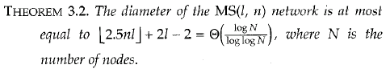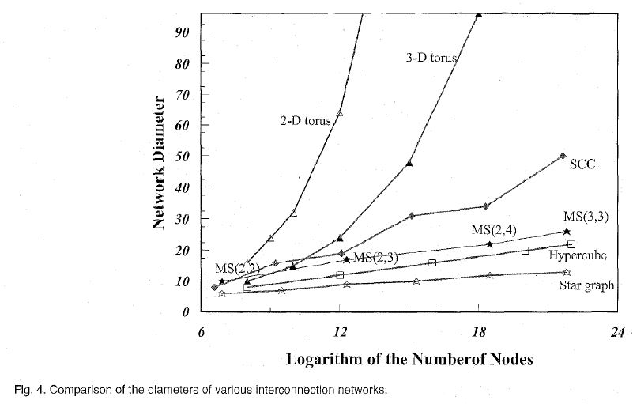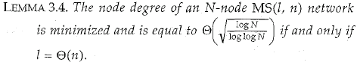
3.4 Near Optimal Diameter
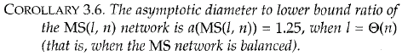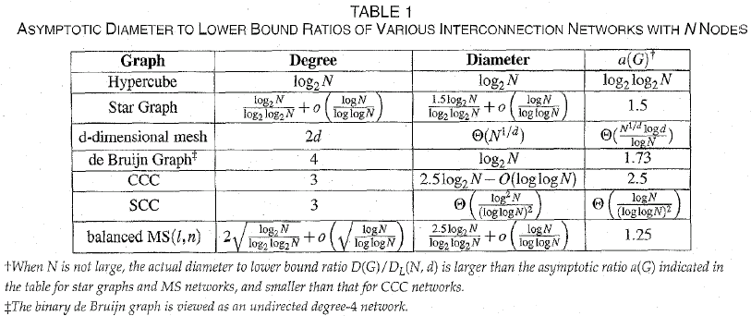
- Parallel Algorithms in MS Networks
4.1 Parallel Algorithms under the Single-Dimension Communication Model
4.2 Emulation of Star Graphs under the All-Port Communication Model
4.3 Embeddings of Trees, Meshes, Hypercubes, and Complete Transposition Graphs
- Conclusions
The MS network and its variant topologies can fit the needs of high-performance interconnection networks and appear to be efficient low-degree alternatives to the star graph for building medium to large-scale parallel architectures.

Created by: Chia-Mao Huang
Date: June 22, 2000

